## Manchester United Home

**First Carousel Image**

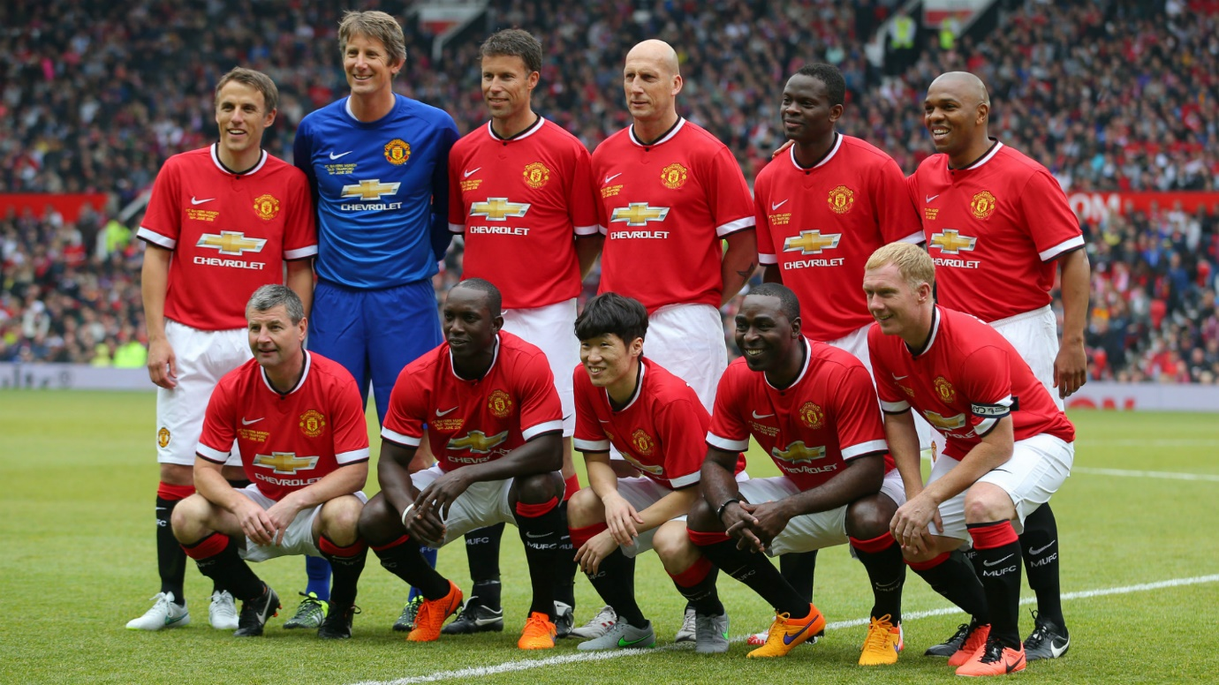

**Second Carousel Image**

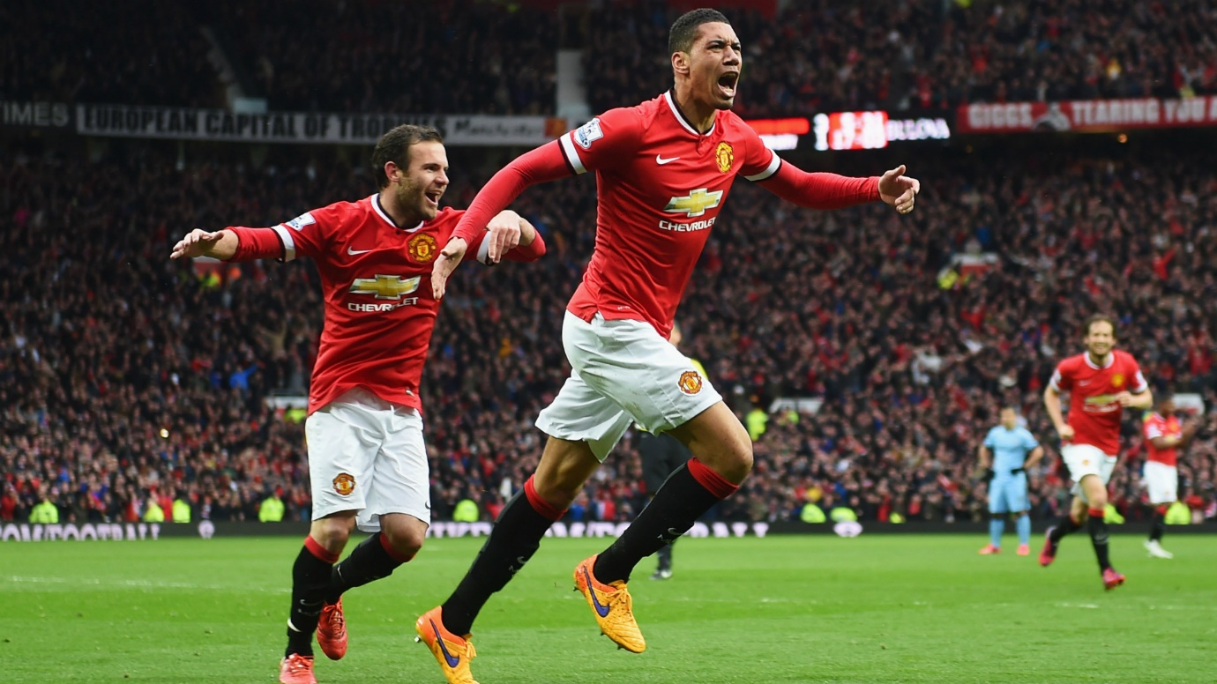

**Third Carousel Image**

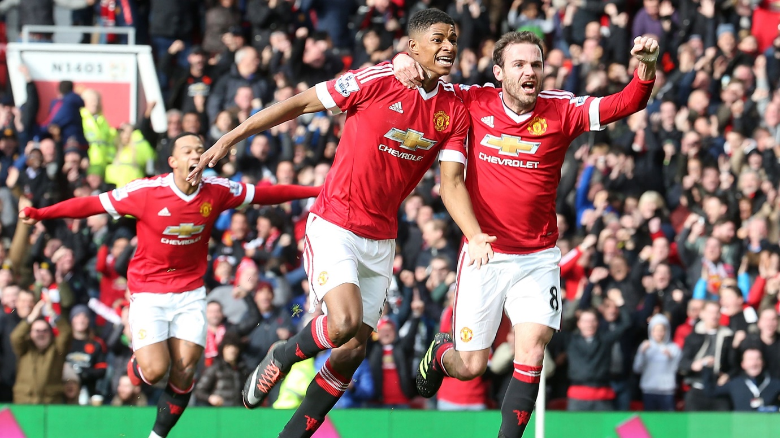

**Football News**

**Rashford Dreams of City Goal at Home**

Manchester United starlet Marcus Rashford might have an opportunity to score his "dream goal" when local neighbours and rivals Manchester City visit Old Trafford on Wednesday night.

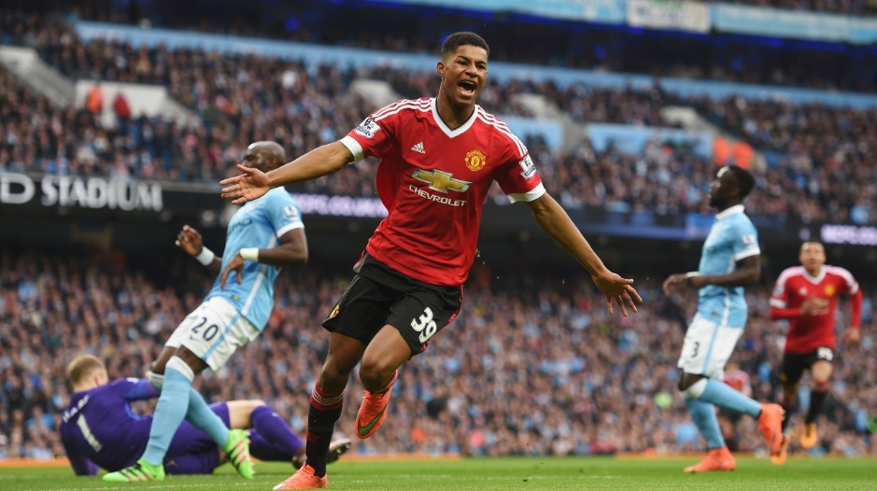

**Main Article Image**

## Manchester United Profile

**Introduction**

Manchester United Football Club is a professional football club based in Old Trafford, Greater Manchester, England, that competes in the Premier League, the top flight of English football. Nicknamed "the Red Devils", the club was founded as Newton Heath LYR Football Club in 1878, changed its name to Manchester United in 1902 and moved to its current stadium, Old Trafford, in 1910.

**The Story Continues**

In 1968, under the management of Matt Busby, Manchester United became the first English football club to win the European Cup. When Alex Ferguson took control, the team won 38 trophies, including 13 Premier League titles, 5 FA Cups and 2 UEFA Champions Leagues, between 1986 and 2013,when he announced his retirement José Mourinho took control and is the club's current manager, having been appointed on 27 May 2016.

**Achievements**

Manchester United have won a record 20 League Titles, a joint-record 12 FA Cups, four League Cups and a record 21 FA Community Shields. The club has also won three European Cups, one UEFA Cup Winners' Cup, one UEFA Super Cup, one Intercontinental Cup and one FIFA Club World Cup. In 1998–99, the club became the first in the history of English football to achieve the treble of the Premier League, the FA Cup and the UEFA Champions League.

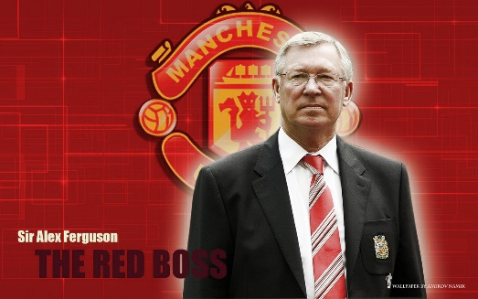 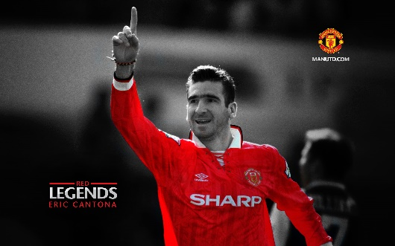

**Profile Image 1 Profile Image 2**

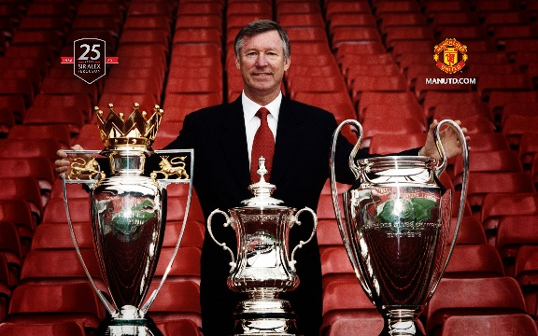

**Profile Image 3**

## Manchester United Fixtures

**October 2016**

|  |  |  |  |  |  |
| --- | --- | --- | --- | --- | --- |
| 26 Oct | EFL Cup | Manchester City | H | 20:00 |  |
| 29 Oct | Premier League | Burnley | H | 15:00 |  |
| **November 2016** | | | | | |
| 03 Nov | UEFA Europa League | Fenerbahce | [A](http://www.manutd.com/en/Fixtures-And-Results/United-Fixtures-And-Results.aspx?pageNo=2) | 18:00 |  |
| 06 Nov | Premier League | Swansea City | [A](http://www.swanseacity.net/page/Home) | 15:00 |  |
| 19 Nov | Premier League | Arsenal | H | 12:30 |  |
| 24 Nov | UEFA Europa League | Feyenoord | H | 20:05 |  |
| 27 Nov | Premier League | West Ham United | H | 16:30 |  |
| **December 2016** | | | | | |
| 04 Dec | Premier League | Everton | [A](http://www.evertonfc.com) | 16:00 |  |
| 08 Dec | UEFA Europa League | Zorya Luhansk | [A](http://www.manutd.com/en/Fixtures-And-Results/United-Fixtures-And-Results.aspx?pageNo=2) | 18:00 |  |
| 11 Dec | Premier League | Tottenham Hotspur | H | 14:15 |  |
| 14 Dec | Premier League | Crystal Palace | [A](http://www.cpfc.co.uk) | 20:00 |  |
| 17 Dec | Premier League | West Brom Albion | [A](http://www.wba.co.uk/) | 17:30 |  |
| 26 Dec | Premier League | Sunderland | H | 15:00 |  |
| 31 Dec | Premier League | Middlesbrough | H | 15:00 |  |
| **January 2017** | | | | | |
| 02 Jan | Premier League | West Ham United | [A](http://www.whufc.co.uk) | 17:15 |  |
| 15 Jan | Premier League | Liverpool | H | 16:00 |  |
| 21 Jan | Premier League | Stoke City | [A](http://www.stokecityfc.premiumtv.co.uk) | 15:00 |  |

**Recent Results Current Standings**

Chelsea 4 – 0 Manchester United Manchester United

Manchester United 4 -1 Fenerbahce Played 11, Goal Difference 3

Liverpool 0 – 0 Manchester United Points 18, Position 6

# Manchester United Team

Manchester United – Current Team

|  |  |
| --- | --- |
| David De Gea Picture  **David De Gea (Goalkeeper)** | C:\Users\Faizan Sheikh\Desktop\Major Project\img\bailly.jpg  **Eric Bailly (Defender)** |
| C:\Users\Faizan Sheikh\Desktop\Major Project\img\jones.jpg  **Phil Jones (Defender)** | C:\Users\Faizan Sheikh\Desktop\Major Project\img\rojo.jpg  **Marcus Rojo (Defender)** |
| C:\Users\Faizan Sheikh\Desktop\Major Project\img\pogba.jpg  **Paul Pogba (Midfielder)** | C:\Users\Faizan Sheikh\Desktop\Major Project\img\lingard.jpg  **Jesse Lingard (Midfielder)** |

|  |  |
| --- | --- |
| C:\Users\Faizan Sheikh\Desktop\Major Project\img\carrick.jpg  **Michael Carrick (Midfielder)** | C:\Users\Faizan Sheikh\Desktop\Major Project\img\memphis.jpg  **Memphis (Winger)** |
| C:\Users\Faizan Sheikh\Desktop\Major Project\img\young.jpg  **Ashley Young (Winger)** | C:\Users\Faizan Sheikh\Desktop\Major Project\img\mata.jpg  **Juan Mata (Attacking Midfielder)** |
| C:\Users\Faizan Sheikh\Desktop\Major Project\img\rooney.jpg  **Wayne Rooney (Striker)** | C:\Users\Faizan Sheikh\Desktop\Major Project\img\ibrahimovic.jpg  **Zlatan Ibrahimovic (Striker)** |

## Manchester United Contact

**Contact Us**

Please contact us using the form below and we will respond as soon as we can.

**Email**

info@manunited.com

**Telephone**

+61 02 9876 5432

**Skype**

ManUnited

**Address**

ManUnited Ltd.

1 Kings Row Avenue

London, England